**RUTGERS, THE STATE UNIVERISTY OF NEW JERSEY**

TERM PROJECT

OPERATION ANALYSIS

Prof. Weiwei Chen

**Mobile Sales Forecasting**

Aakash Bhatt

Sai Ronith Reddy Bongunoori

Manvika Sharma

Abhishek Tegginamat

Mythili Rajaram

**TABLE OF CONTENTS**

1. Abstract………………………………………2
2. Introduction………………………………….3
3. Methodologies……………………………….4
4. Linear Regression Model………………...4
5. Deseasonalization………………………..7
6. Adjusting Seasonal Forecasts…………….8
7. Safety Stock………………………………….11
8. Conclusion…………………………………...12

**ABSTRACT**

In order to thrive in today's world of technical advancements and global market competition, product and service providers must create new items or improve existing ones. Because technical advancements have reduced the life cycle for many items, fast technological growth in the high-tech sector makes global competition even more difficult for enterprises in today's marketplace. The use of older models may depreciate, or the purchase rate of older models may decrease, as new phones are released each year. Proper forecasting is required to maintain track of supplies and inventories. Stocking up on the basis of a simple average or a moving average might result in stock outs or surplus inventory. To achieve this, seasonality must be removed. Forecasting utilizing linear regression and deseasonalization will provide a more accurate picture of inventory stock-ups.

**INTRODUCTION**

Sales prediction, which is the focus of this study, is a more traditional but nonetheless fascinating application of forecasting. As markets become more global and competition becomes more severe, increasing an organization's operational efficiency is critical. When corporations must stretch their resources thin and consumers have an abundance of options, every advantage a company can wring out counts. If a corporation can match a product's demand with just the correct amount of supply, no sales will be lost owing to a lack of inventory, and no costs will be incurred due to overstocking. Sales forecasting analyzes previous data to anticipate future sales, enabling more informed decisions like allocating or diverting existing inventories, or increasing or decreasing future production. From 2019 through 2021, we have sales statistics for the iPhone 11 pro from the firm **Big C Mobiles**, divided into quarters. The information pertains to three models: 64GB, 256GB, and 512GB. Each quarter's dataset includes the quantity sold, selling price, discount, and revenue generated. Our goal is to provide accurate sales forecasts for the coming quarters that would allow the firm to plan optimum inventory.

**METHODOLOGIES**

DATA CLEANING

We can do some basic data cleaning and remove columns like X, Y, and Z that aren't needed. Here, the columns named “Quarter”, “Selling Price”, “Discount %” and “Revenue” are not used in the analysis as they are dependent on other data which the company is not willing to disclose. We divided the data into three worksheets for three different models: 64GB, 256GB, and 512GB, and ran the calculations separately on each one. We begin with the second period because the first period is just a short number of days for which they sold the newly launched model. It would behave as outlier in the model if we include it.

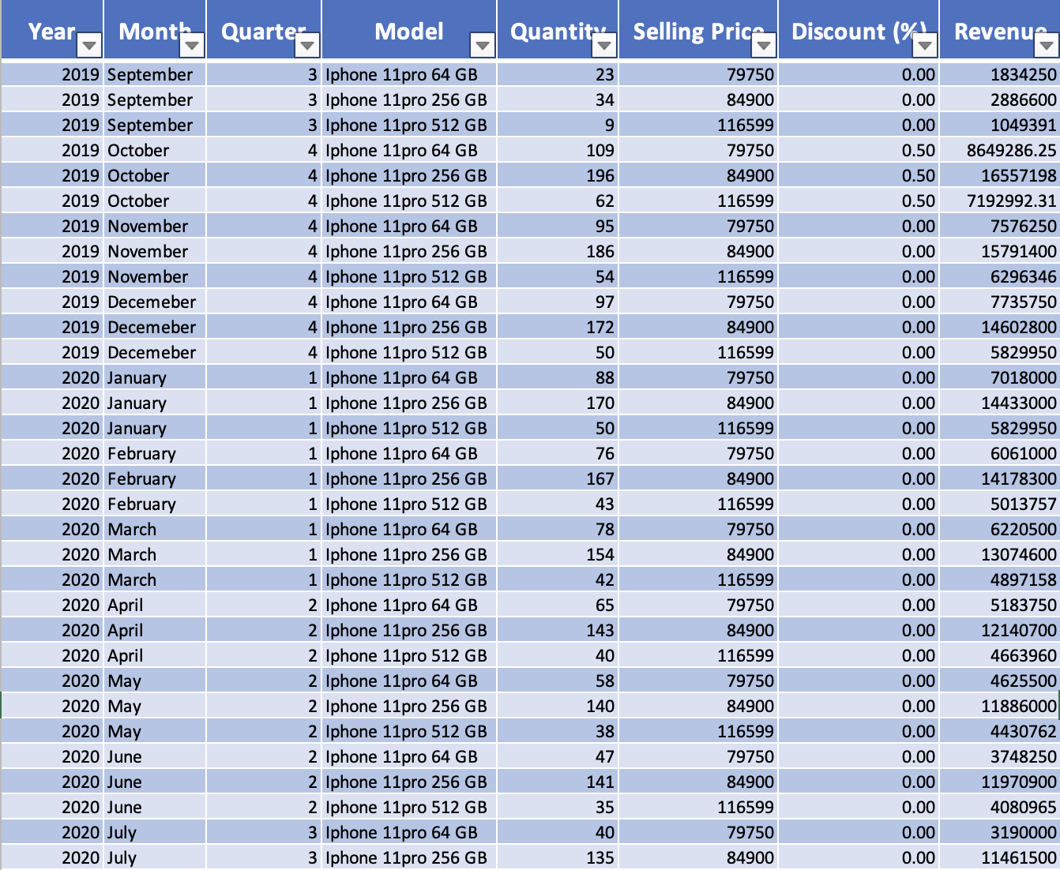

LINEAR REGRESSION MODEL

By calculating the basic average, the company forecasted stock gains for the next quarters. Exponential Smoothing and Moving Average lags behind the trend, resulting in large differences between estimates and real data. Smoothing models don't work since the data isn't stationary or has a trend or seasonality to it. We run the linear regression model on the dataset to get the forecasted value for a better prediction.

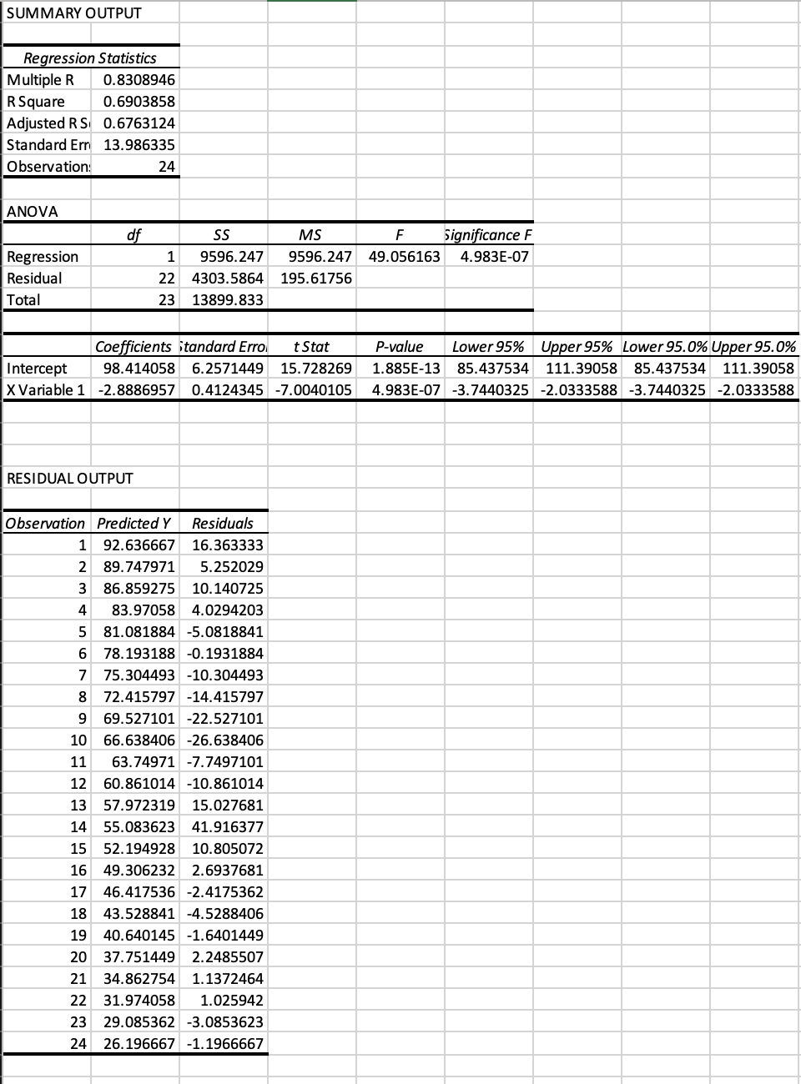

According to linear regression, the r square value is decent, but there is a pattern in residuals plot and the graph of sales shows a seasonality tendency.

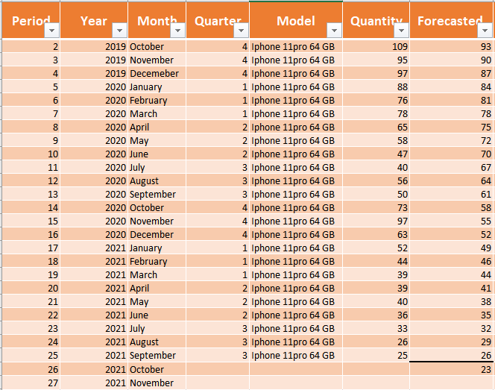

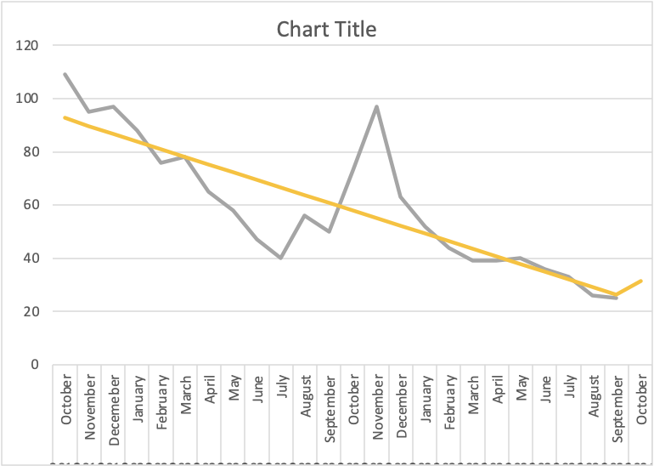

DESEASONALIZATION

Our project focuses on using Deseasonalization, the process of removing seasonality from a data series by identifying the seasons and computing each period index. This can be done by calculating the ratio of Actual value and forecasted value obtained using forecasting approach. Period index is then calculated. It is the average of ratio obtained for corresponding periods. To create a modified time series with no seasonality and on the updated time series, apply any applicable forecasting approach (for example, regression) – Restore seasonality by multiplying each forecast of the time series by the relevant period index to create the adjusted forecasts which captures the seasonality in data.

We observe seasonality in the above graph and when seasonality is present in a time series, we apply the following approach, which assumes no seasonality but changes the data to account for it:

1. Using some forecast model, calculate the associated unadjusted forecast for each period observation in the time series.

2. Calculate Ratio = Observed / Forecast for each observed period value.

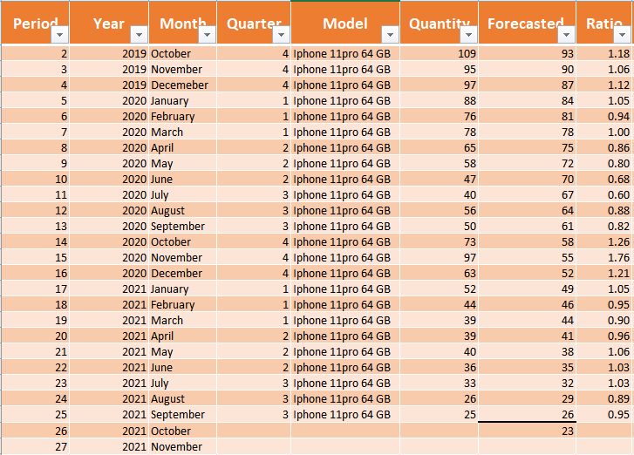

ADJUSTING SEASONAL FORECASTS

The period index or average ratio is then calculated for each month (average of October 2019 and 2020. Also, if/when it exists, October 2021)

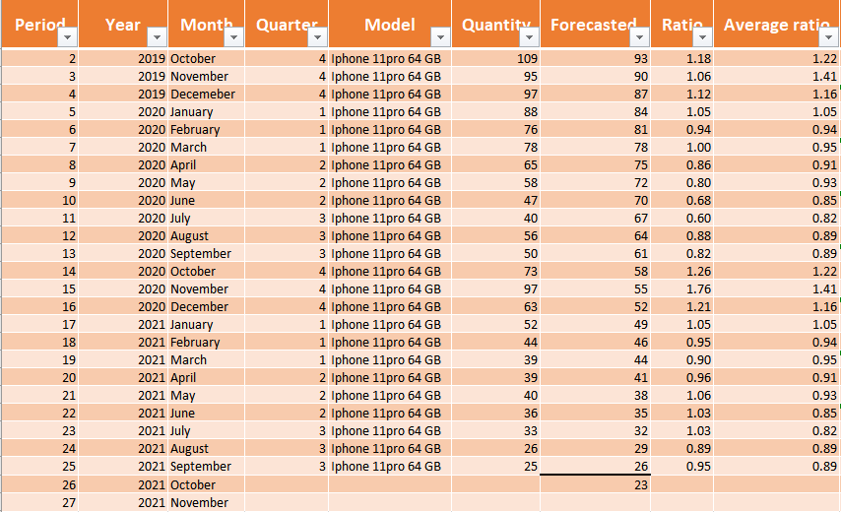

Finally, we compute the Seasonally Adjusted Forecast = Unadjusted Forecast x Period Index (average ratio)

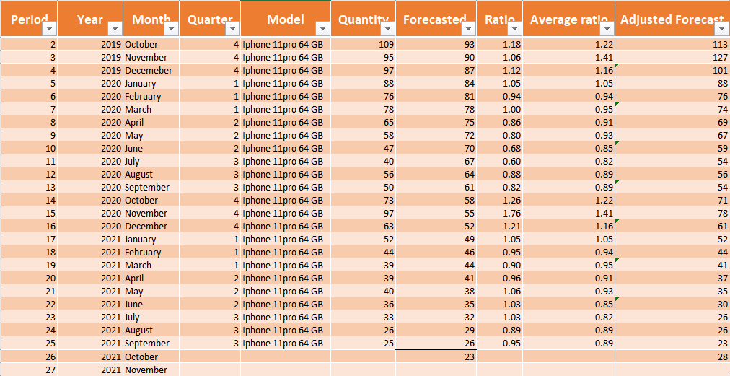

From the above calculations, we get the forecasted sale for the month of October 2021 which captures the seasonality in data.

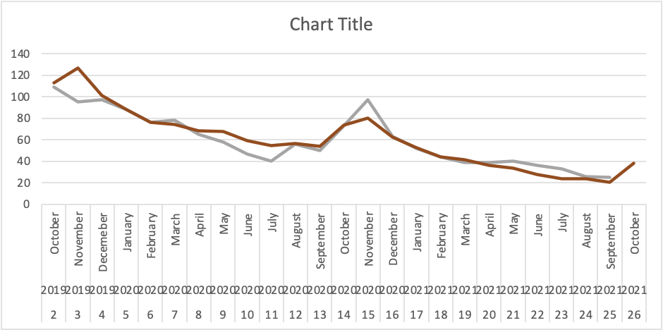

In the graph above, the grey line is the actual forecast and the red line gives the adjusted forecast.

The same procedure is followed for 2 other models as well, i.e. for the 256gb and 512gb. The calculations have been shown in the Excel spreadsheet.

**SAFETY STOCK**

The firm also informed us that there had been several instances when they experienced stock-outs and they lost the business opportunity. This may have been because of their inability to forecast the demand accurately and using the Naïve methods of forecast.

As per the information that we received from the firm, it takes about 1 week for the order to arrive from their supplier after placing the order. The details about the supplier however, were not shared.

Based on this information, we provide the following values for safety stock for each of the Mobile phone models so as to be able to serve the customers with 95% of service level.

-Lead time = 1 week

-95% service level

**For 64 GB**

Standard Deviation = 24.6

Safety stock (S*) = zα *σ * √τ

**Safety stock** = normsinv(0.95)×24.6×√1= **40**

**For 256 GB**

Standard Deviation = 49.9

Safety stock (S*) = zα *σ * √τ

**Safety stock** = normsinv(0.95)×49.9×√1= **82**

**For 512 GB**

Standard Deviation = 12.9

Safety stock (S*) = zα *σ * √τ

**Safety stock** = normsinv(0.95)×12.9×√1= **21**

**CONCLUSION**

Seasonal patterns are captured from time-series data in our study. The company utilized to forecast stock gains for the coming quarters by using the basic average. We now have seasonally adjusted or deseasonalized data, which has been cleansed of its seasonal patterns. The company can estimate better and more accurate forecasts to stock up supplies using this strategy and the resulting prediction.

We also provide a safety stock that the firm should maintain to serve the customers as per the defined service levels.